31.46: 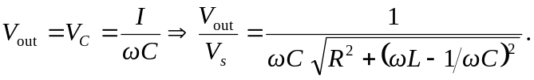
If is large: 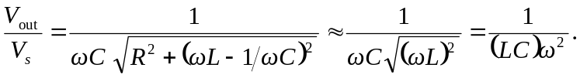
If is small: 